AGRO SENSOR READINGS

Stores sensor data collected from agricultural fields at regular time intervals
Each document represents one sensor reading from one device at a specific date and time

Contains environmental data such as:
- Temperature
- Humidity
- Rainfall
- light intensity

Includes soil-related parameters:
- soil moisture
- soil pH
- fertilizer usage

Tracks crop-related information:
- crop type
- season
- crop health status
- estimated yield
- pest risk level

Helps identify irrigation requirements using the irrigation_needed field
Uses anomaly_flag to mark abnormal or unusual sensor readings
device_id and location fields allow comparison across different regions and sensors.

Separate date and time fields support daily analysis and time-based queries.

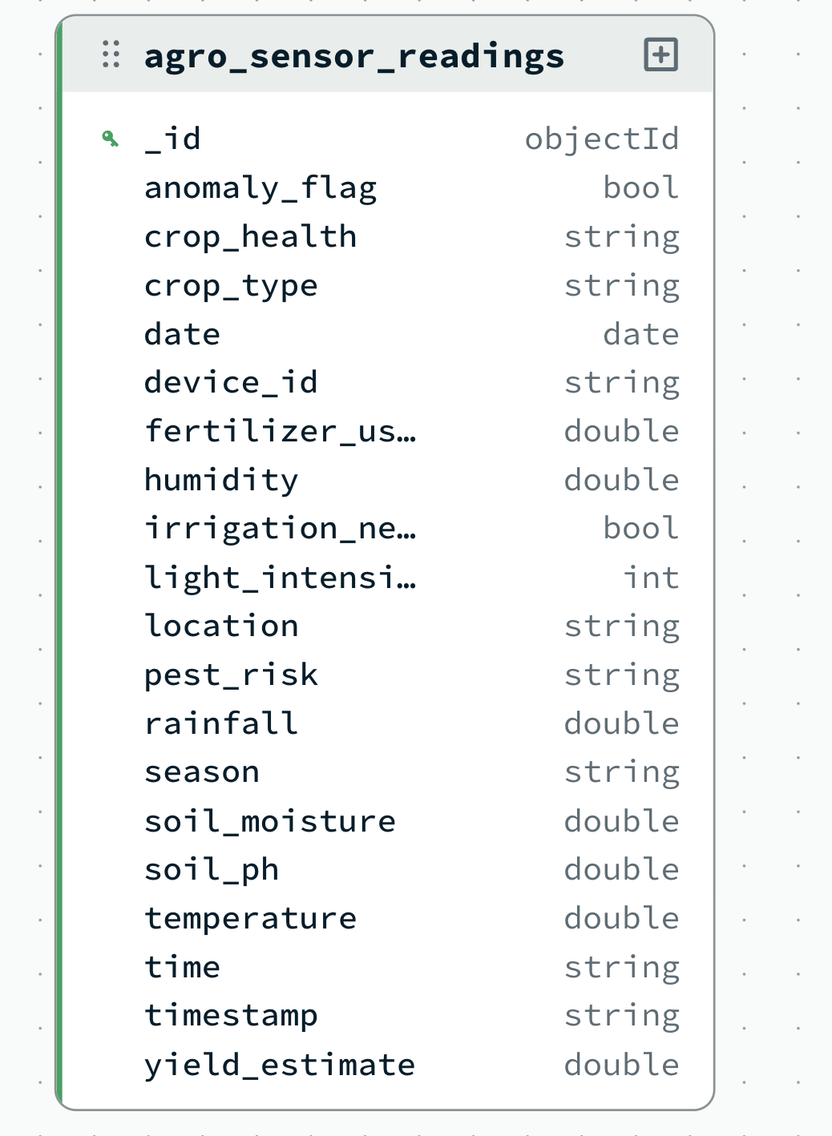

Overall document sample:
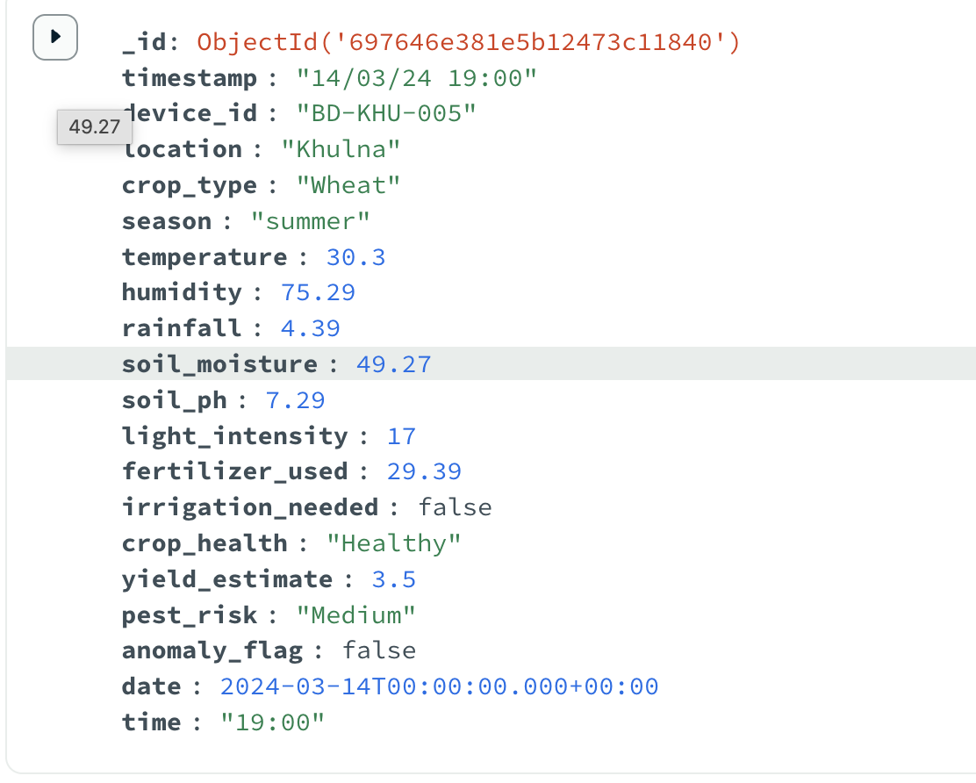

QUERY PERFORMED FOR PERFORMANCE MEASUREMENT.

db.agro_sensor_readings.find({
location: "Dhaka",
date: {
$gte: ISODate("2024-03-01T00:00:00Z"),
$lt: ISODate("2024-04-01T00:00:00Z")
}
}).explain("executionStats")

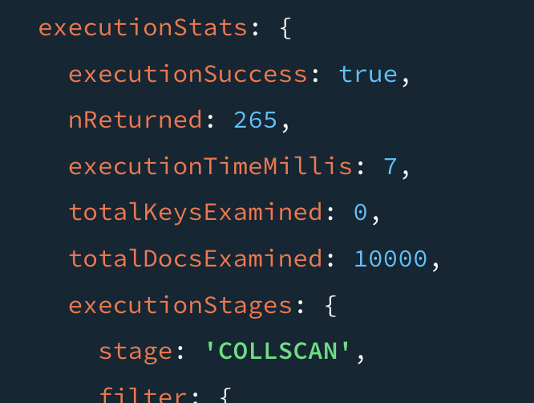

db.agro_sensor_readings.createIndex({ location: 1, date: 1 })

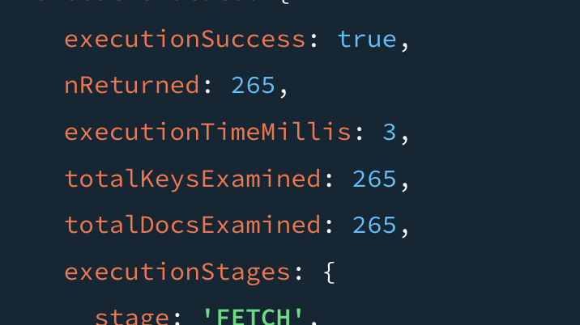

Other indexing created:

db.agro_sensor_readings.createIndex({ date: 1 })
db.agro_sensor_readings.createIndex({ device_id: 1, date: -1 })
db.agro_sensor_readings.createIndex({ location: 1, date: 1 })
db.agro_sensor_readings.createIndex({ crop_type: 1, date: 1 })
db.agro_sensor_readings.createIndex({ anomaly_flag: 1, date: 1 })

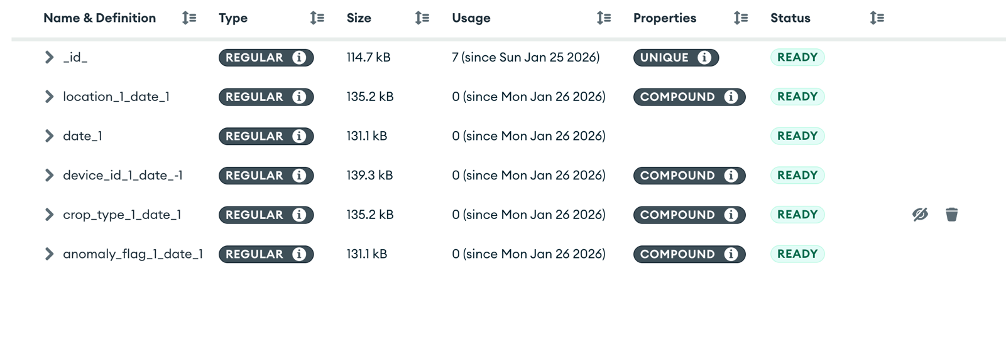

1 Daily average temperature per location
db.agro_sensor_readings.aggregate([
{
$group: {
_id: { location: "$location", date: "$date" },
avgTemp: { $avg: "$temperature" }
}
},
{ $sort: { "_id.date": 1 } }
])
What it does:
Shows how average temperature changes daily for each city.
Useful for climate trend charts.
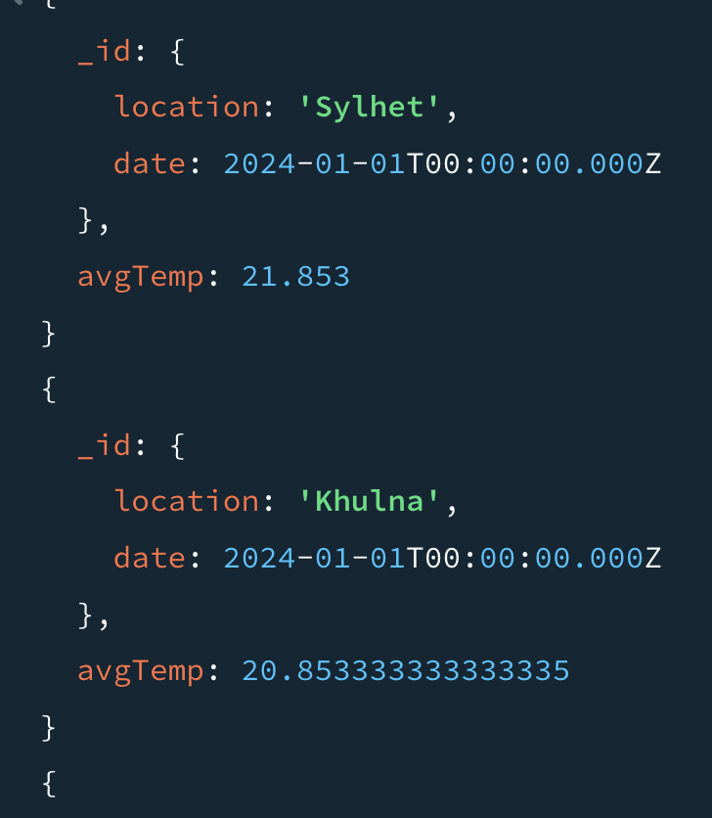

2 Total rainfall per location (monthly)
db.agro_sensor_readings.aggregate([
{
$group: {
_id: { location: "$location" },
totalRainfall: { $sum: "$rainfall" }
}
}
])
What it does:
Calculates how much rain each location received.
Helps compare water availability across regions.
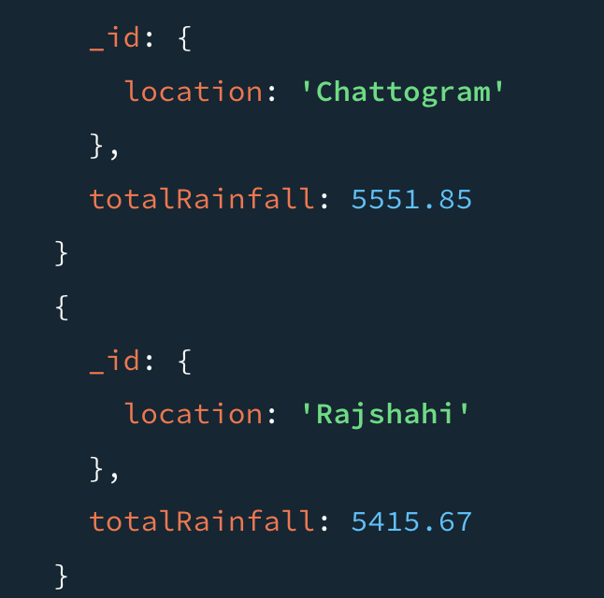

3 Latest sensor reading per device
db.agro_sensor_readings.aggregate([
{ $sort: { date: -1 } },
{
$group: {
_id: "$device_id",
latestReading: { $first: "$$ROOT" }
}
},
{
$project: {
_id: 0,
device_id: "$_id",
date: "$latestReading.date",
location: "$latestReading.location",
temperature: "$latestReading.temperature",
soil_moisture: "$latestReading.soil_moisture",
crop_health: "$latestReading.crop_health"
}
}
])What it does:
Fetches the most recent data from every sensor device.
Used for live monitoring dashboards.
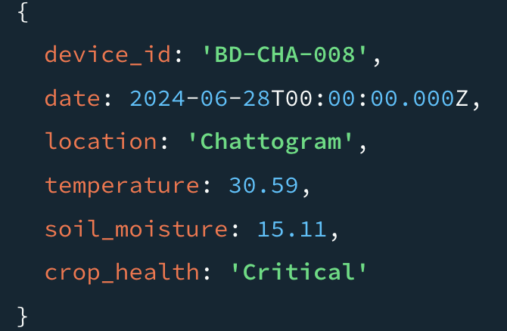

4 Number of anomalies per location
db.agro_sensor_readings.aggregate([
{ $match: { anomaly_flag: true } },
{
$group: {
_id: "$location",
anomalyCount: { $sum: 1 }
}
}
])
What it does:
Counts abnormal sensor readings by city.
Helps identify problematic regions quickly.
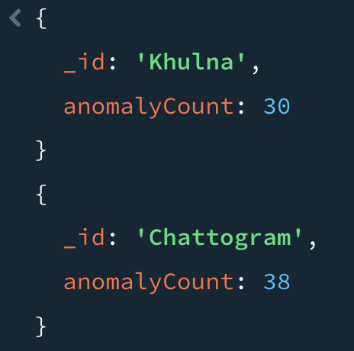

5 Crops currently under stress
db.agro_sensor_readings.find(
{ crop_health: "Stressed" },
{ crop_type: 1, location: 1, date: 1 }
)
What it does:
Lists crops that are not healthy.
Useful for alerting farmers or agronomists.

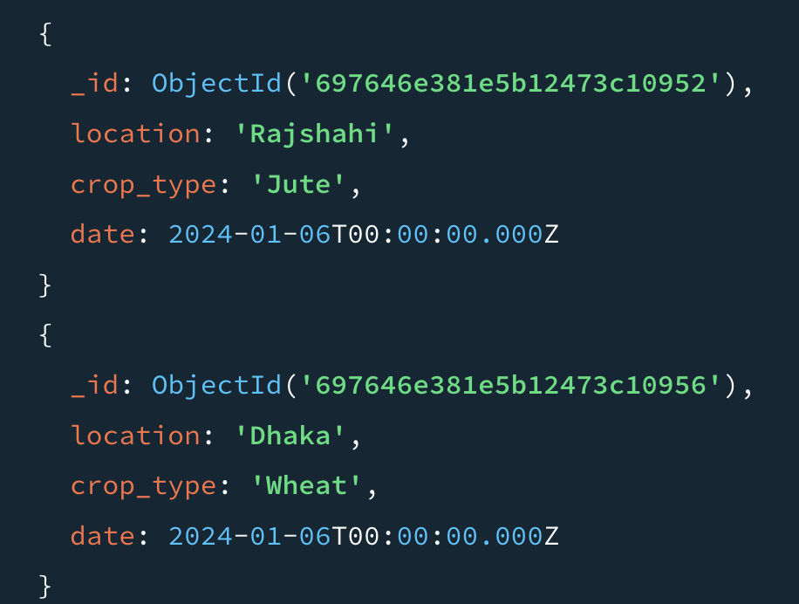

6 Irrigation required today
db.agro_sensor_readings.find(
{
irrigation_needed: true,
date: {
$gte: ISODate("2024-03-15T00:00:00Z"),
$lt: ISODate("2024-03-16T00:00:00Z")
}
},
{
"_id":0, "crop_type": 1, "location": 1, "device_id":1
}
)
What it does:
Shows which farms need watering today.
Helps optimize irrigation planning.
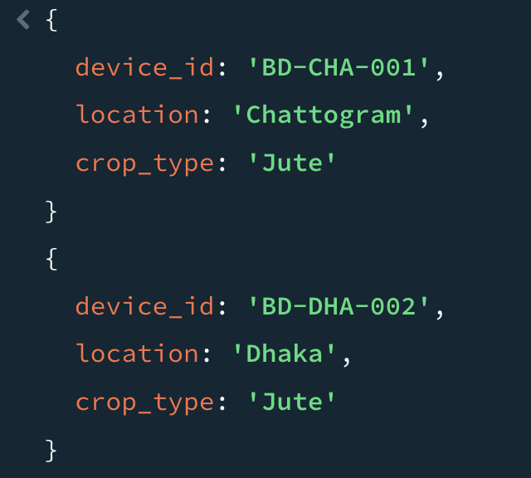

7 Average yield estimate per crop
db.agro_sensor_readings.aggregate([
{
$group: {
_id: "$crop_type",
avgYield: { $avg: "$yield_estimate" }
}
}
])
What it does:
Calculates expected yield for each crop type.
Useful for production forecasting.
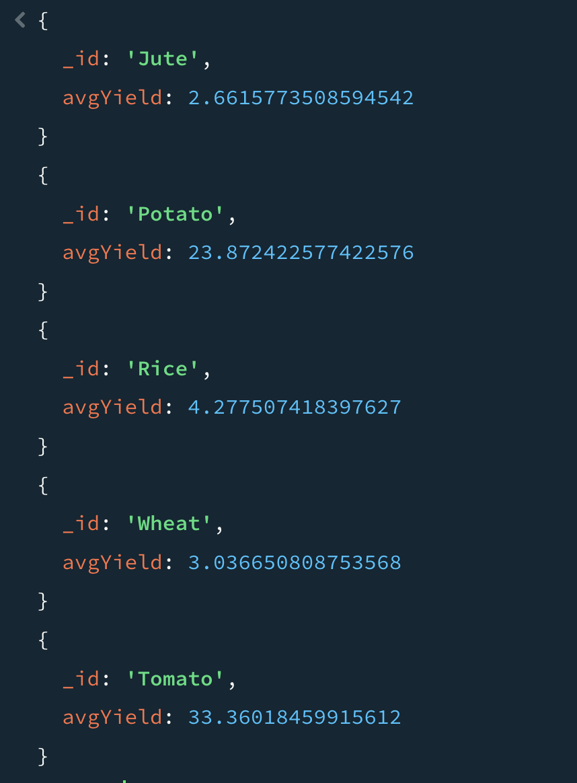

8 Pest risk distribution
db.agro_sensor_readings.aggregate([
{
$group: {
_id: "$pest_risk",
count: { $sum: 1 }
}
}
])
What it does:
Shows how many readings fall under low/medium/high pest risk.
Useful for preventive pest control decisions.
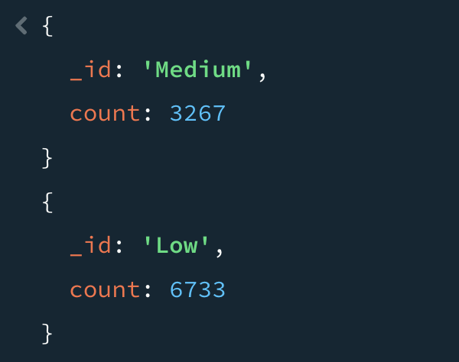

9 Devices with frequent anomalies
db.agro_sensor_readings.aggregate([
{ $match: { anomaly_flag: true } },
{
$group: {
_id: "$device_id",
anomalyCount: { $sum: 1 }
}
},
{ $sort: { anomalyCount: -1 } }
])
What it does:
Identifies faulty or problematic sensor devices.
Helps in maintenance and sensor calibration.
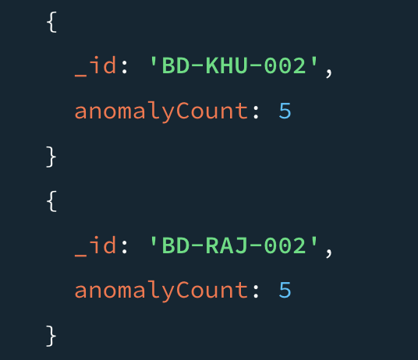

10 Soil moisture trend over time
db.agro_sensor_readings.aggregate([
{
$group: {
_id: "$date",
avgMoisture: { $avg: "$soil_moisture" }
}
},
{ $sort: { "_id": 1 } }
])
What it does:
Tracks soil moisture changes day by day.
Useful for irrigation and drought analysis.
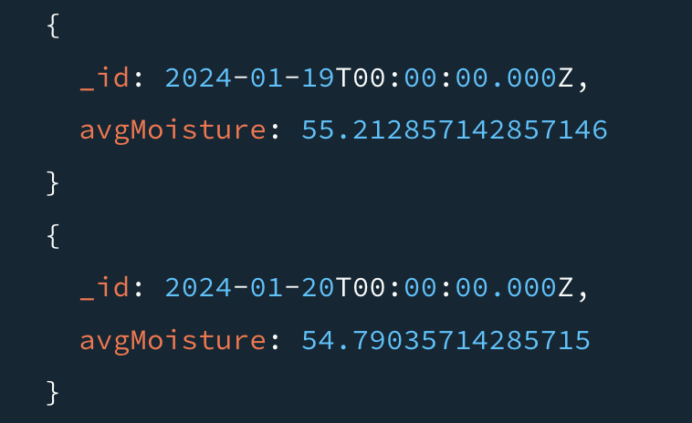

11 Crop performance by season
db.agro_sensor_readings.aggregate([
{
$group: {
_id: { crop: "$crop_type", season: "$season" },
avgYield: { $avg: "$yield_estimate" }
}
}
])
What it does:
Compares how crops perform across seasons.
Helps decide optimal planting time.
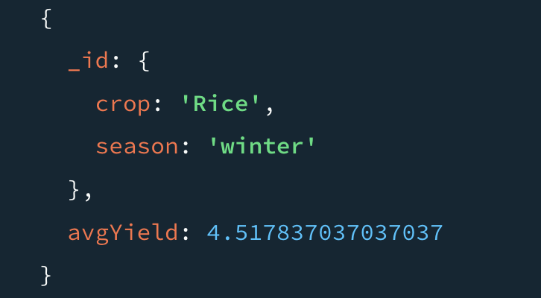

12 Heat stress detection
db.agro_sensor_readings.find({
temperature: { $gt: 35 }
}
{
"_id":0 , "location":1
}
)
What it does:
Finds periods of extreme heat.
Useful for heat-stress alerts and crop protection.
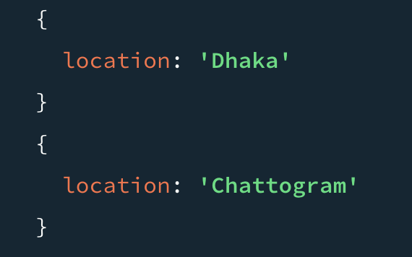

13 Light intensity vs crop health
db.agro_sensor_readings.aggregate([
{
$group: {
_id: "$crop_health",
avgLight: { $avg: "$light_intensity" }
}
}
])
What it does:
Analyzes relationship between sunlight and crop health.
Helps in greenhouse or shading decisions.
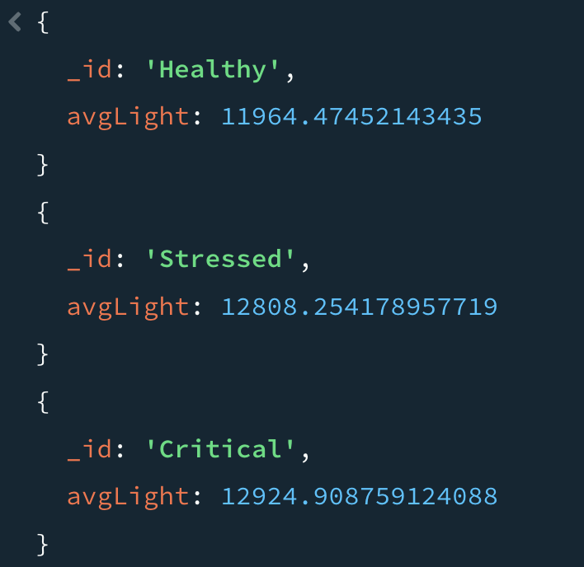

14 Location-wise average soil pH
db.agro_sensor_readings.aggregate([
{
$group: {
_id: "$location",
avgSoilPH: { $avg: "$soil_ph" }
}
}
])
What it does:
Shows soil acidity by location.
Useful for fertilizer and soil treatment planning.
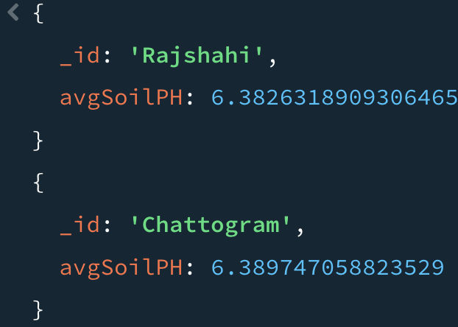

15 Yield trend over time
db.agro_sensor_readings.aggregate([
{
$group: {
_id: "$date",
avgYield: { $avg: "$yield_estimate" }
}
},
{ $sort: { "_id": 1 } }
])
What it does:
Tracks how crop yield changes over time.
Useful for long-term agricultural planning.
